Week9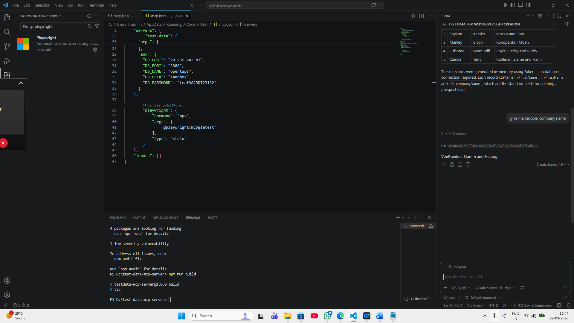

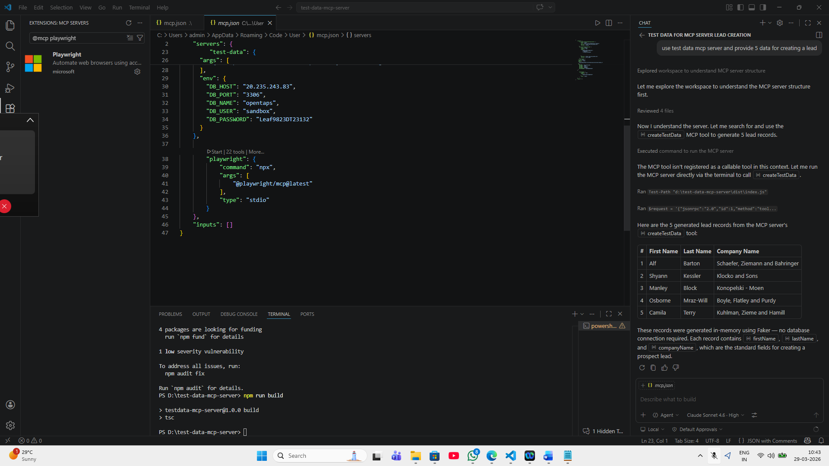

Week 10:
Feature: Search the buses city from source to destination places
As a user
I want to search buses from Chennai to Bangalore
So that I can take a trip on that day
@smoke @SearchBus
Scenario: Verify user can Search particular buses from source to destination
Given I navigate to Red Bus application
When I enter values in From Field as "Chennai"
And I select "Chennai" in Recent Searches
And I select the "Bangalore" at "To" input Field
And I click the Search Buses button

